Sean Higgins

November 16, 2017

CS 562 – Adv. Real-Time Graphics

Prof. Herron

CS 562 Adv. Real-Time Graphics – Proj. 3 Report

Overview:

Easily one of the more difficult projects thus far, implementing and testing image based lighting has proven to be a challenge. This lighting technique is one of the more noticeable additions of realism with regards to real-time rendering. Instead of only considering the ambient light from the scene as some vague, constant term, we instead try to account for it in a more realistic fashion, using the skydome environment image as a light source.

Environment Map:

Reading the environment map in is a process in and of itself—using a regular image as a texture simply won’t work, as the 0-1 color values are too low to give us the subtle lighting effects we’re after. Instead, we use HDR—high dynamic range—images, which store color values as full floating point values. This requires some slight tweaks and changes as to how we calculate lighting values in the shaders, but these conversions are fairly straightforward and trivial.

Ambient Diffuse & Specular Values:

The core of the new lighting calculations is in two parts: the diffuse and specular terms for the ambient lighting. Realistically, both are an infinite integral—taking light from every input direction and calculating what fraction of it reaches our camera, a feat which is clearly impossible to realistically calculate in any finite amount of time, much less real-time graphics. In order to approximate these, we split the lighting equation up into its diffuse and specular portions, then approximate them separately. For the specular portion, we use the Monte Carlo integration technique—smartly choosing light input directions according to some probability, evaluating the light given that direction, then dividing that value by the probability we chose. The last step in this technique is to divide the cumulative sum of all of these evaluations by the number of evaluations—this is the exact same technique ray tracing uses to draw various scenes. For the diffuse portion, we pre-calculate the integral, as it only depends on the HDR image we choose for our skydome, and, for a given point, we simply look up the value of the diffuse portion of the lighting equation.

Final Output – Low Ball Shininess 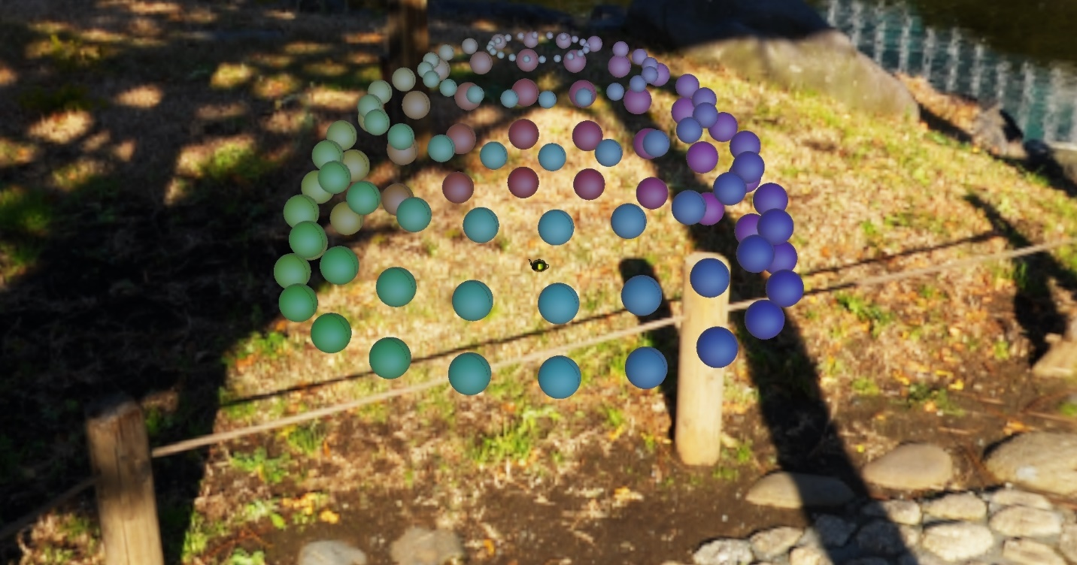

Teapot Zoom-In – Only Specular Reflection (Diffuse vals. At ~0.1) 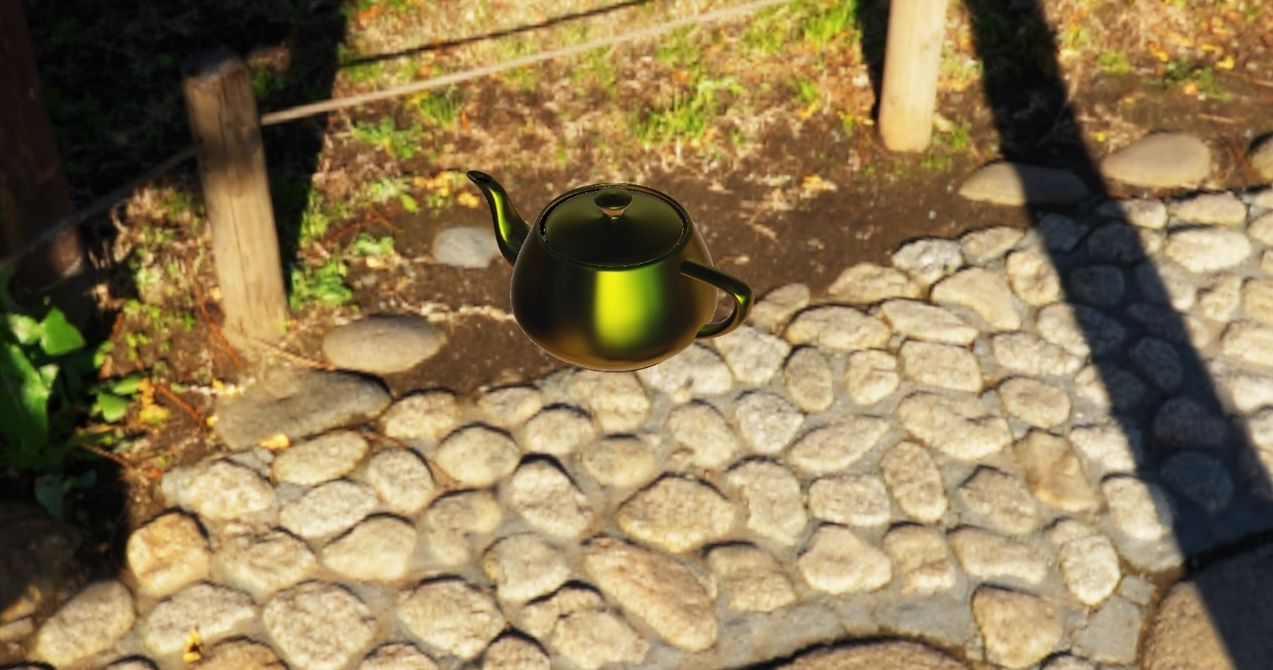

Final Output – High Ball Shininess 